Technical Design Template

Team: | Phantom | ITN: | 132345 |  |  | Solution Design
 |  | Pipeline(s): | SOLUTION_TEST
  Feature Number(s): 306189

Team: 1
ITN: 1
Solution Design 1
Pipeline(s): 1
1 Introduction 1
1.1 Link to Requirements Document 1
1.2 Requirements 1
User Story 1
2 Design Discussion 2
1.3 Use Case 2
1.4 Class Diagrams 2
3 Implementation 3
1.5 Files 3
4 Testing Considerations 5
5 Screenshots 6

Introduction
This is a web-based application used to manage the contacts for a firm. The contacts are stored in a secure location on an internal server and the user is able to log in to the system using their access details.
The user can perform CRUD operations based on the privileges provided to them by the administrator.

Link to Requirements Document
https://jira2.cerner.com/browse/DEVACDMY-5165

Requirements
.

User Story
User Story ID | MH3
Story | Save contact details
Description | The user is able to save the new contact details to the database. The entered contact details are sent to the server which after validation are added into the database.

Design Discussion

Use Case
The use case for this user story can be seen as give below.

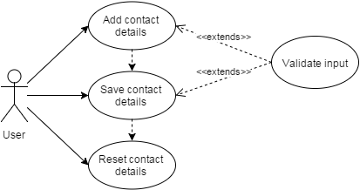

Figure 1 Use Case for adding new contact

Class Diagrams

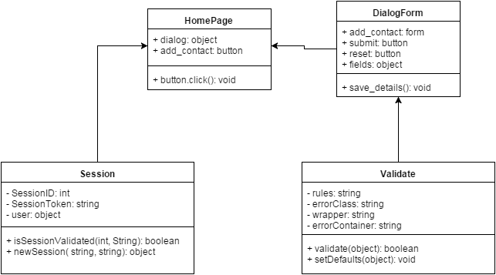
Figure 2 Class Diagram for adding contact

Implementation

This user story is to build a dialog form where the user enters the contact details to add to the database. The implementation details are as follows:

- The user can click on the add button to open a dialog form.
- The dialog form consists of fields that are mandatory and some are optional.
- The user enters the contact information using the keyboard.
- The jQuery validation plugin is used to validate the input given in the fields.
- The validation rules are as follows:
- The title, first name, last name, work contact and the email are mandatory fields while the rest are optional.
- Email address should be a valid email address.
- The work and home contact numbers should be digits and no letters.
- The date of birth should be in proper format.
- The notes field is incorporated to store any other relevant information about the person.
- The clear all button can be used to clear up all the fields and get a blank form.
- The validation functions are called upon the key up event of the keyboard and the focus out event of the html element. On clicking the submit button, the validation script is called on all the elements.
- The invalidated fields are marked with ‘error_msg’ class which is used by the css file to highlight those fields.

Files

File | home.html
Description | This is the home page where the user lands after successful authentication. It is the dashboard fir the user to add, view, update and delete contact and their details.
Pseudo Code | function collectData(){  // collect data from the input fields of the ‘add_contact’ form  }  function saveContactDetails(){  data = collectData();  data = parseIntoPostData(data);  req = prepareAjaxReq(data);  sendAndReceiveResponse( server, req);  }
Passive (Yes/No) | No

File | css/home.css
Description | It is the css file for the “home.html” page defines the styling for the various html elements.
Passive (Yes/No) | No

File | add_contact.php
Description | This is the php script that receives the validated contact details in a JSON format through an asynchronous HTTP request. The JSON data is parsed and the information is validated again on the server side in php. It connects to the database and through suitable SQL query adds the contact and its details to the database.
Pseudo Code | function addContact (data){  getData();  if ( connectToDatabase() == true){  if ( validateData() == true){  SQL query = prepareSQLStatement();  query.execute();  Message(‘’Contact added successfully”);  }else{  Message(“Could not add. Some problem with the provided data.”);  }  }else{  Message(“Sorry, we are unable to process your request.”);  }  }
Passive (Yes/No) | Yes

Testing Considerations
Navigate to the home.html and follow the steps given below for each test case.

#Test Cases | Test Steps | Expected Results
TC 1 | - Click on the add button  - Click on the submit button | The details are not sent over to the server. The required fields are highlighted and the user is asked to fill up these details.
TC 2 | - Click on the add button  - Enter valid input  - Click on submit button | A message shows saying the given user has been added. The given contact details are added to the database and can be confirmed by the MySQL admin.
TC 3 | - Click on the add button  - Enter valid input  - Enter work contact or email address that already exists in the database  - Click on submit button | An error message displays saying “The provided work contact number and/or email already exist in the database.”
TC 4 | - Click on the add button  - Enter valid input  - Shutdown MySQL server  - Click on submit button | An error message displays saying “Cannot process your request. Please try again later.”

Screenshots

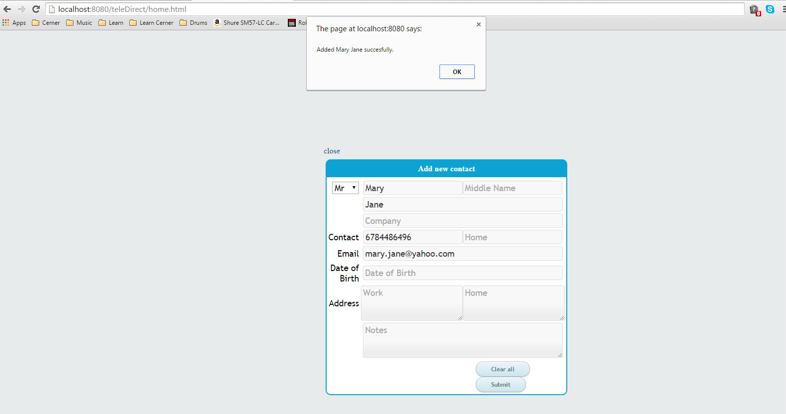
Figure 3 Saved new contact successfully

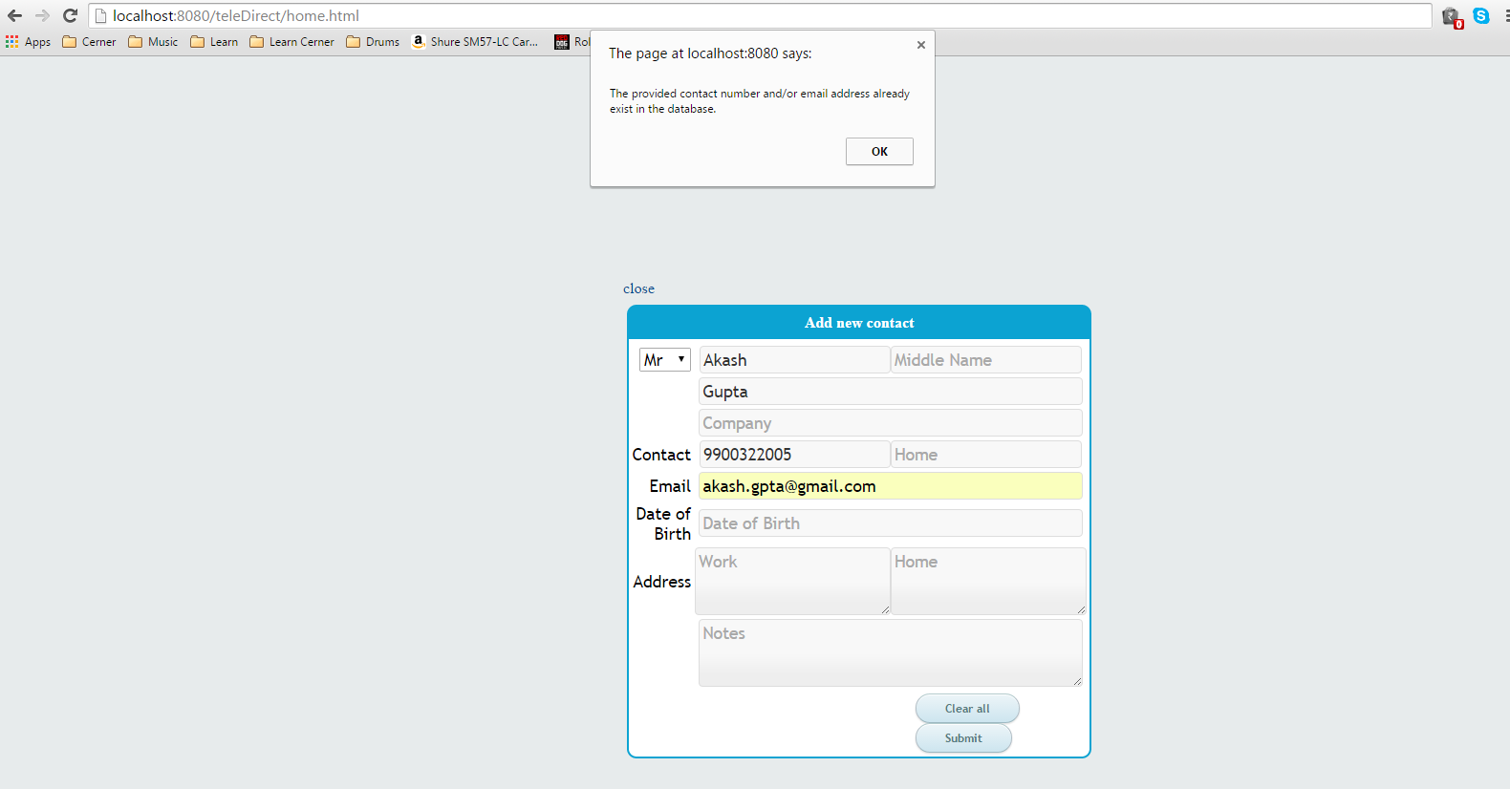
Figure 4 Could not add duplicate contact

